Synchronization of Situational Awareness Between Critical Infrastructure and the Public Sector Using Unmanned Aerial Systems (UAS)

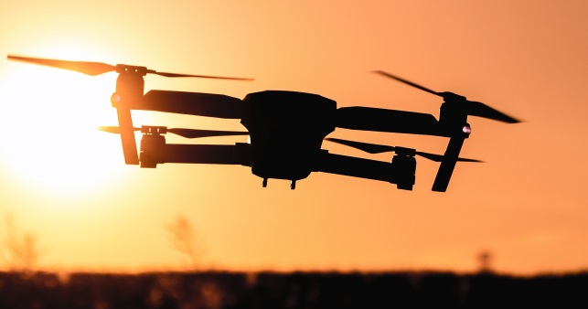
The Pacific Northwest Economic Region (PNWER) and its Center for Regional Disaster Resilience (CRDR) was awarded a 2018 National Infrastructure Protection Plan (NIPP) Security and Resilience Challenge project for critical infrastructure. The project sought to develop methodologies to allow for the rapid inspection of critical infrastructure in post-disasters using drones (also called Unmanned Aerial Systems (UAS)). This information can then be shared with state level emergency management agencies to establish better situational awareness and a common operating picture.
The Gap
86% of the nation’s critical infrastructure is owned and operated by the private sector. There is a need for rapid damage assessment of these critical infrastructures immediately following a disaster. Emerging drone technology is allowing for an expedited and detailed damage assessment of infrastructures by owners and operators. To accomplish this work requires that the private sector have access to disaster zones to conduct damage assessments and then be able to share information rapidly with state emergency management agencies so that a common operating picture can be established.
Project Scope
This project scope included the development of plans, procedures, processes, and mechanisms for the collection and exchange of damage information. This information will assist both infrastructure owners and the public sector to obtain faster situational awareness on the status of their infrastructures, and other interdependent infrastructures that may impact their ability to provide services, and products to their customers. This information can then be transmitted to state EOCs and used to create a common operational map that can be shared with the federal government, lower level jurisdictional organizations and the private sector.
The project worked with four states in the Pacific Northwest: Idaho; Montana; Oregon, and Washington. The first goal was to establish a working group of interested public and private sector infrastructure owners and operators within each state. Public and private critical infrastructure owners and operators were then invited to a workshop in each of the four states. Participants were briefed on relevant UAS state and federal regulations, and discussed their needs and concerns about partnering with government offices and their respective state.
A CONOPS for access into disaster zones and the sharing of information was prepared for each state as a result of these workshops. These CONOPS include a process for private sector CI owners to gain access into disaster areas in each of the states. This element of the CONOPS uses either existing state access control methodologies or developed a simplified process for access to CI so that drones can be used to gather damage assessment information. Communications channels and data file types for transmission were also outlined in the CONOPS for streamlined communication during an event.
A demonstration drill was conducted in Washington with one infrastructure owner and operator (Olympic Pipeline). This drill used the established process for a private CI owner to obtain access to a disaster zone, fly a simulated damaged area with a UAS, and transmit simulated disaster damage information to the state Emergency Operations Center (EOC). The outcome of the drill was extremely useful to both the WA EOC and the National Guard as they further develop the Domestic Operations Awareness and Assessment Response Tool (DAART) tool for use across all fifty states.
Finally, the longer-term goal of this project is to demonstrate this UAS to EOC situational awareness feed at scale in real-time during the Cascadia Rising II exercise planned for 2022.
Project Team
The Pacific Northwest Economic Region (PNWER) worked in cooperation with other public and private stakeholders. This will include personnel from ports, rail roads, energy providers, pipelines, water systems, ferry systems, state and local transportation agencies and state level emergency managers, and other public and private sector organizations who own and operate critical infrastructures, or upon whom these infrastructures are dependent.
Project Deliverables
The project steps were as follows:
Step 1: Invite participation by each of the four Pacific Northwest States - Idaho, Montana, Oregon, and Washington, followed by the formation of a user’s group within each of the four states, that will work to address UAS information sharing. (Spring 2019)
Step 2: Conduct a workshop in each of the aforementioned states to enlist the support of participating infrastructures and garner information particular to that state. (Spring / Summer 2019)
Step 3: Write a CONOPS, one for each participating state, that provides the framework for the sharing of information and for access into disaster zones by critical infrastructures. (Summer 2019)
Step 4: Conduct a drill in one state to provide a “proof of concept” for the CONOPS. (September 2019)
Step 5: Submit a final report summarizing the results of the project. (September 2019)
Stakeholder Commitment
Stakeholders were invited to commit to providing time and resources to assist in this effort. Our partners included the Washington State Emergency Operations Center, the National Guard, Olympic Pipeline, Oregon Department of Aviation, Montana Division of Disaster and Emergency Services, and the Idaho Office of Emergency Management.
Project Timeline
Work began in December 2018. All contract deliverables were accomplished by September 30, 2019.
Contacts
Eric Holdeman, Director, CRDR, 253-376-6683, eric.holdeman@pnwer.org
Steve Myers, Senior Program Manager, CRDR, 206-443-7723, steve@pnwer.org

